

SSPIDEATHON
ORGANISED BY
SHARDA SCHOOL OF PHARMACY, PETHAPUR, GANDHINAGAR
On 20th February, 2026

PROGRAMME REPORT

The Student Startup and Innovation Policy (SSIP) launched by the Government of Gujarat has been successful in promoting entrepreneurship and innovation among students. The policy has helped create a favorable environment for startups to grow and thrive in the state.
Sharda School of Pharmacy, Pethapur, Gandhinagar has organized introductory session on SSIP on 20th March, 2026.
Date: 20th February, 20246
Time: 10:00-11:00am
Topic: Start Up and Managing Startups
Students of various colleges of Gujarat were participated in the introductory session with their respective ideas and innovation. Total 60 students have participated in the session.
The session was delivered by Dr Disha Suthar, Professor at Sharda School of Pharmacy, Pethapur, Gandhinagar. The program was coordinated by Dr Khushboo Vaghela, SSIP Coordinator at Sharda School of Pharmacy, Pethapur, Gandhinagar.
Madam has given talk on the SSIP introduction, Difference between Business and startup, how to choose any idea for startup and many more.
Its great session for the students to understand and make interest in the SSIP.

GLIMPSE OF SESSION

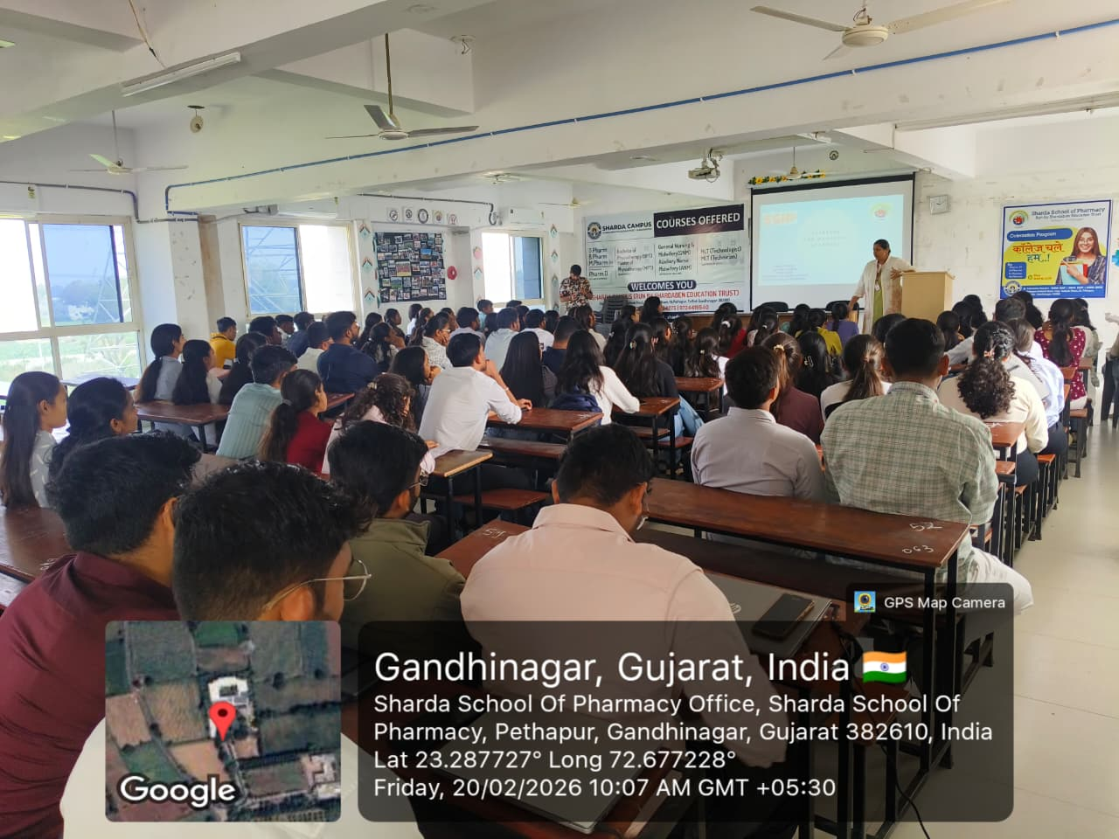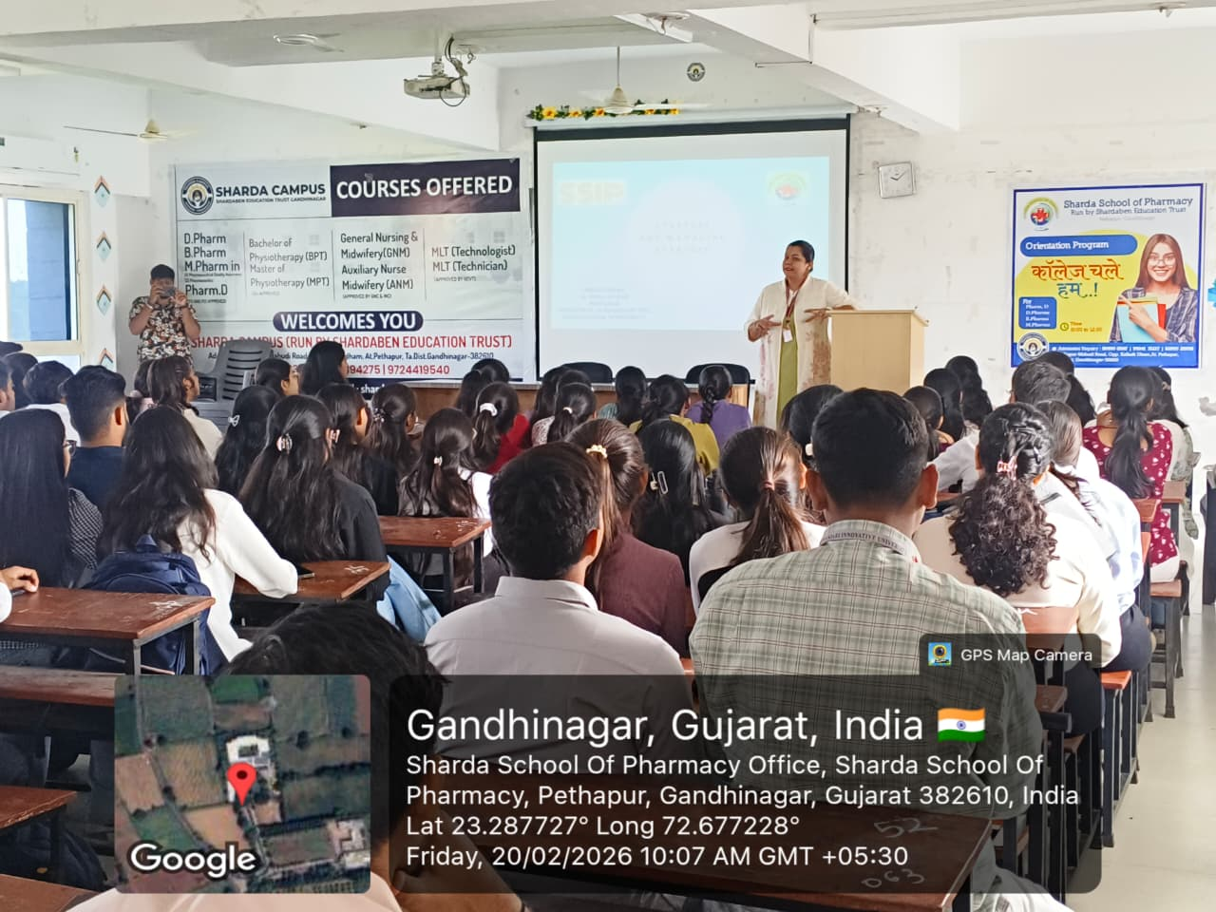

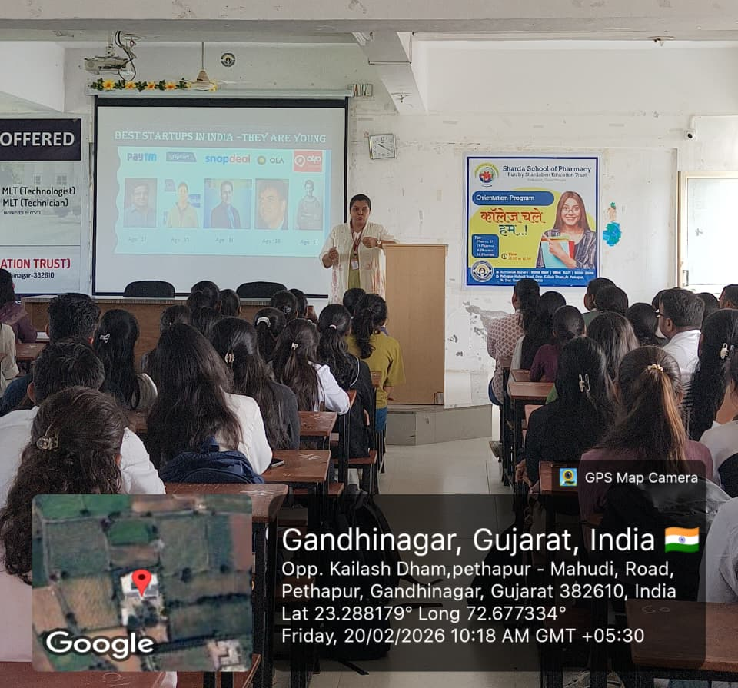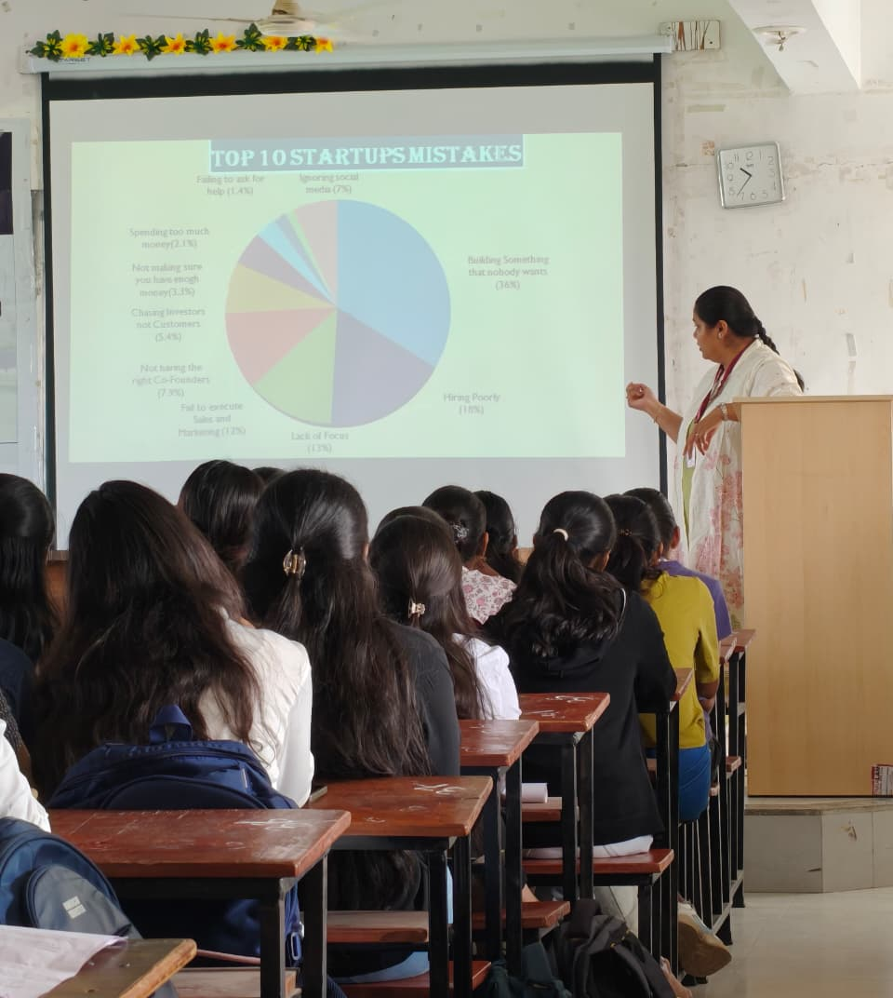

Sign of SSIP coordinator:
Sign of Principal:

